This design presents a pragmatic, scalable solution for managing 4.5M contacts and 150K entities with complex relationship mapping requirements.

**1. Data Model Design**

**Schema Diagram**

When designing the data model, I focused on balancing normalization with query performance needs.

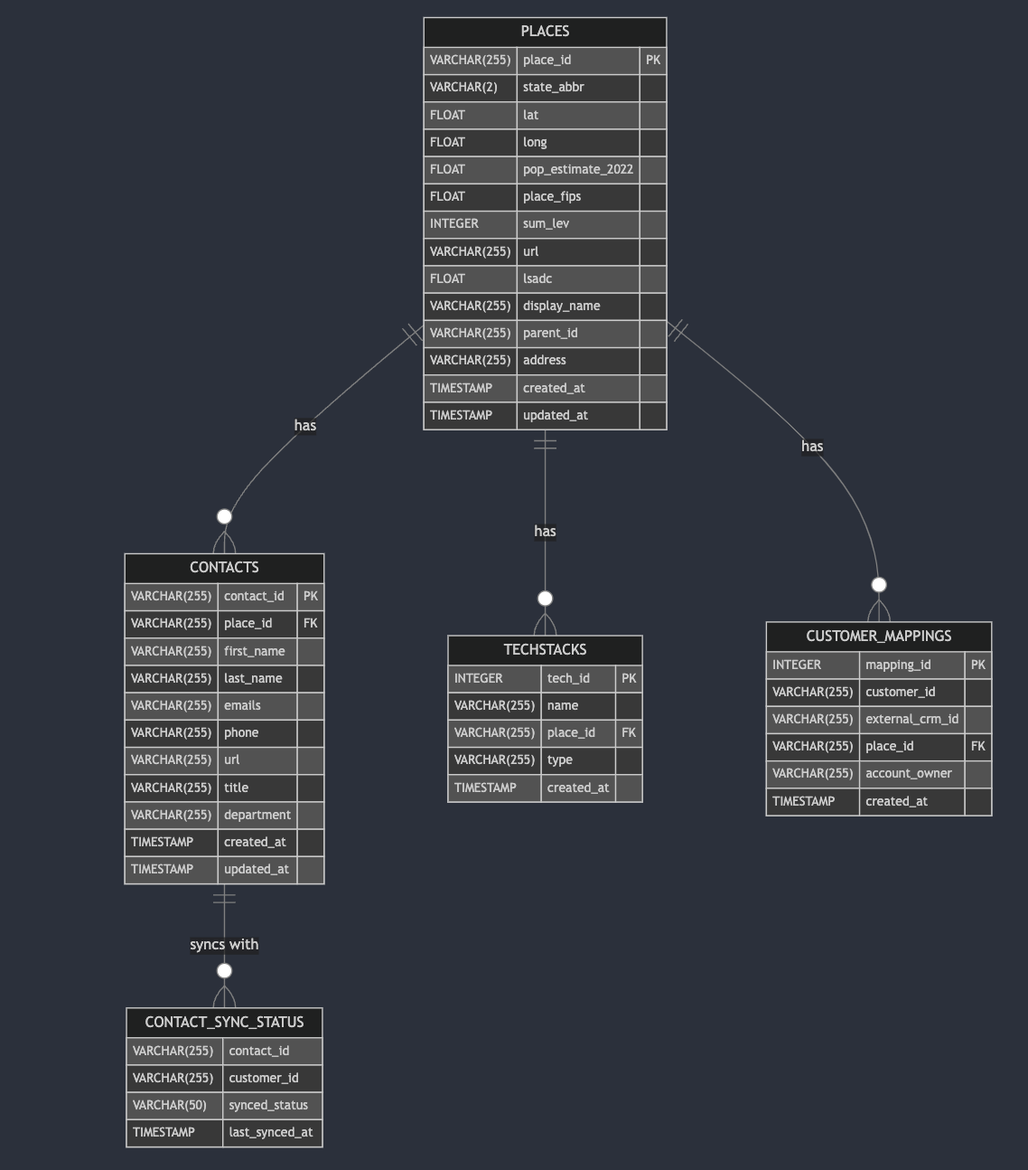

I've organized the data into five core tables:

* **places**: Where we store our main entity data - think cities, counties, etc.
* **contacts**: The people associated with those places
* **techstacks**: What technologies each place is using
* **customer_mappings**: How our platform connects to our customers' CRMs
* **contact_sync_status**: Tracking which contacts have been synchronized

**My thought process:**

* Separate places and contacts for clear many-to-one relationship
* Isolate techstacks to handle multiple technologies per place
* Create specialized tables for customer mappings rather than trying to force this into existing tables
* Track sync status in a dedicated table to handle the complexity of multi-customer synchronization

### **Indexing Approach**

With millions of contacts, smart indexing is critical. I'd approach this pragmatically:

1. **Start with the basics**: Primary and foreign key indexes on all tables
2. **Add targeted indexes** for common query patterns:
   * B-tree indexes on filter columns (state, account_owner)
   * GIN indexes on text fields we need to search (email, title)
3. **Monitor and adjust**: Once we see real query patterns, we'll refine our indexes

We need to be careful not to over-index - that would hurt write performance. I typically aim for a 90/10 rule: optimize for the queries that make up 90% of our workload.

### **Customer-Specific Mapping Approach**

The customer mapping challenge is interesting. I considered three options:

1. **JSON/JSONB columns**: Store customer-specific data as JSON in the places table
2. **EAV model**: Create a generic key-value store for customer attributes
3. **Dedicated mapping tables**: Create specific tables for customer relationships

I chose option **3** because:

* It provides better query performance than JSON for structured data
* It's more maintainable than an EAV model
* It allows for clear indexing strategies

The downside is more tables to manage, but the clarity is worth it.

### **Customer-Specific Mappings**

This is where things get interesting. Each customer has their own CRM and wants to view data in their context. My solution:

1. **Territory Management**: We use the customer_mappings table to link our entities to their CRM records. This lets them run queries like:

-- Show me Bob's territory

SELECT p.display_name, p.state_abbr

FROM places p

JOIN customer_mappings cm ON p.place_id = cm.place_id

WHERE cm.customer_id = 'Customer_A' AND cm.account_owner = 'Bob'

2. **Sync Status Tracking**: The contact_sync_status table lets us track which contacts have been pushed to which CRM systems:

-- What's been synced to Customer B?

SELECT c.first_name, c.last_name, c.emails

FROM contacts c

JOIN contact_sync_status css ON c.contact_id = css.contact_id

WHERE css.customer_id = 'Customer_B' AND css.synced_status = 'synced'

**Search architecture**

When I look at this search problem, I see a classic tension between simplicity and power. We need to let users search across multiple dimensions:

* Contact details like titles and emails
* Relationships between entities and contacts
* Customer-specific IDs and mappings
* Complex combinations of these factors

My first instinct was to ask: "Do we really need a specialized search engine like Elasticsearch here?" It's tempting to reach for the shiny tool, but I've learned the hard way that added complexity often isn't worth it until you've maxed out simpler approaches.

## **My Proposed Approach**

I'd start with a PostgreSQL-centric solution, focusing on three key components:

### **1. Smart Indexing Strategy**

PostgreSQL's search capabilities are more powerful than most people realize. With the right indexes, we can get excellent performance:

-- For text searching (like titles containing "finance")

CREATE INDEX idx_contacts_title ON contacts USING gin(to_tsvector('english', title));

-- For email partial matching

CREATE INDEX idx_contacts_email ON contacts USING gin(emails gin_trgm_ops);

-- For common filtering patterns

CREATE INDEX idx_customer_owner ON customer_mappings(customer_id, account_owner);

The tradeoff here is write performance vs. read performance. Each index makes writes slightly slower but makes searches faster. Since we're more read-heavy in this application, I lean toward more indexes.

### **2. Materialized Views for Common Patterns**

For those complex queries that join contacts, entities, and technologies, I'd create materialized views:

CREATE MATERIALIZED VIEW contact_entity_search AS

SELECT

c.*,

p.display_name as entity_name,

p.state_abbr,

p.population,

array_agg(t.name) as technologies

FROM contacts c

JOIN places p ON c.place_id = p.place_id

LEFT JOIN techstacks t ON p.place_id = t.place_id

GROUP BY c.id, p.id;

The key tradeoff: these views take storage space and need refreshing, but they dramatically speed up complex searches. I generally refresh them during low-traffic periods.

### **3. Query Builder Pattern**

For those custom UI filters, I'd implement a query builder that converts UI selections into optimized SQL:

# Simplified example

def build_search_query(filters):

base_query = "SELECT * FROM contact_entity_search"

conditions = []

if filters.get('title'):

conditions.append("title ILIKE '%{}%'".format(filters['title']))

if filters.get('technology'):

conditions.append("'{}' = ANY(technologies)".format(filters['technology']))

if conditions:

base_query += " WHERE " + " AND ".join(conditions)

return base_query

The tradeoff: We sacrifice some query optimization that would come with hand-tuned SQL for the flexibility to handle arbitrary user filters.

## **Scaling Considerations & Tradeoffs**

As the data grows, we'll face new challenges. Here's my thinking on scaling:

### **Read/Write Separation**

At some point, search queries will compete with write operations. I'd separate these concerns:

* Direct writes to the primary database
* Route search queries to read replicas
* Refresh materialized views on the replicas

Tradeoff: This adds complexity to the architecture but prevents search from impacting core operations.

### **Potential Elasticsearch Integration**

If text search volume grows significantly, we might eventually need Elasticsearch:

def route_query(search_params):

if is_complex_text_search(search_params):

return elasticsearch_search(search_params)

else:

return postgres_search(search_params)

Tradeoff: Elasticsearch gives us better text search performance at the cost of maintaining data synchronization between systems.

### **The Partitioning Question**

For very large contact tables (10M+), I'd consider partitioning:

CREATE TABLE contacts (contact_id, ...) PARTITION BY RANGE (created_at);

The tradeoff: Partitioning adds complexity but can dramatically improve performance for time-based queries and maintenance operations.

## **Why I Think This Works**

I've chosen this approach because:

1. It starts simple but has clear upgrade paths as we scale
2. It leverages PostgreSQL's underappreciated search capabilities
3. It balances immediate needs with future flexibility

In my experience, the biggest mistake in search architecture is over engineering early. This approach gives us a solution that works well now while leaving room to evolve as we learn more about actual usage patterns.